Project Design Phase-II
Technology Stack (Architecture & Stack)

Date | 5 October 2026
Team ID | SWTID-2026-4912
Project Name | AI StudyBuddy
Maximum Marks | 4 Marks

Technical Architecture:
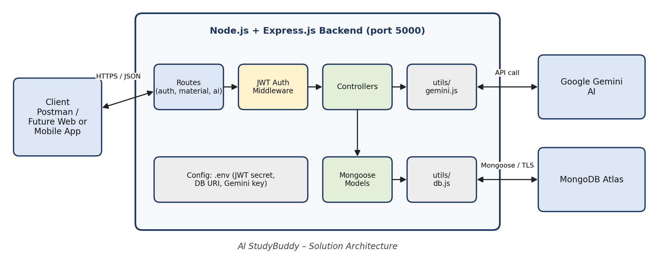
Figure 1: AI StudyBuddy Technical Architecture
Table-1 : Components & Technologies:
S.No | Component | Description | Technology
1. | User Interface | API client used to send requests (web/mobile client planned for later) | Postman
2. | Application Logic-1 | Registration, login, and JWT-protected routes | Node.js, Express.js, JWT, bcryptjs
3. | Application Logic-2 | Study material upload and storage | Express controllers, Mongoose
4. | Application Logic-3 | AI summary, flashcards, quiz, and study-plan generation | Gemini utility (utils/gemini.js)
5. | Database | Collections: User, Material, Summary, Flashcard, Quiz, StudyPlan | MongoDB (NoSQL), Mongoose
6. | Cloud Database | Cloud-hosted database service | MongoDB Atlas
7. | File Storage | Study content is stored as text in the database; no separate file storage | Not used
8. | External API | Generates educational content from prompts | Google Gemini API
9. | Machine Learning Model | Generative AI model for learning content | Google Gemini
10. | Infrastructure | Local development server on port 5000 | Local system, Visual Studio Code, npm
Table-2: Application Characteristics:
S.No | Characteristics | Description | Technology
1. | Open-Source Frameworks | Open-source runtime, framework, and ODM | Node.js, Express.js, Mongoose
2. | Security Implementations | Password hashing, token-based access control, secrets in environment file | bcryptjs, JWT, .env
3. | Scalable Architecture | Layered, modular REST design with stateless authentication | Routes, controllers, models, middleware
4. | Availability | Cloud-hosted database and AI service | MongoDB Atlas, Google Gemini
5. | Performance | Asynchronous, non-blocking request handling | Node.js, Express.js

